According to Intelli, the Netherlands diabetes care devices market was valued at USD 1,016.67 million in 2024 and is projected to reach USD 2025.64 million by 2032, growing at a CAGR of 9.9% from 2024 to 2032.

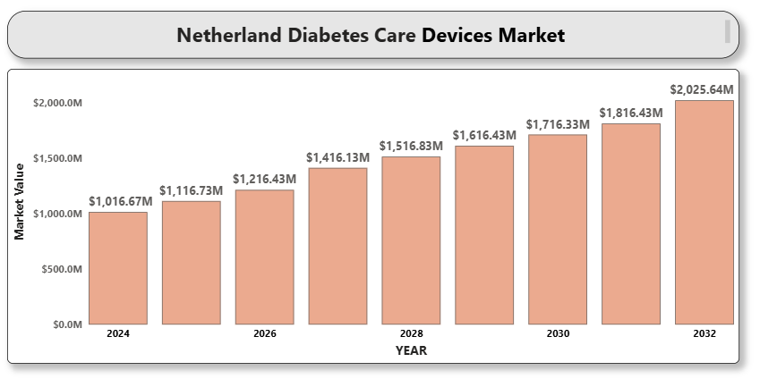

The market is driven by the increasing prevalence of diabetes, technological advancements in monitoring and insulin delivery systems, and rising demand for more personalized and efficient treatment options. Diabetes care devices, including blood glucose meters, continuous glucose monitoring (CGM) systems, insulin pumps, and related accessories, play a crucial role in managing both Type 1 and Type 2 diabetes. These devices help patients monitor their blood sugar levels, adjust insulin doses, and maintain optimal glucose control, thus improving overall health outcomes and quality of life. As digital health solutions, including mobile apps and cloud-based platforms, integrate with diabetes care devices, the demand for advanced, connected solutions is further accelerating. Additionally, factors such as an aging population, increasing healthcare awareness, and supportive healthcare policies are contributing to the market’s growth, positioning the Netherlands as one of the leading regions for diabetes care device innovations.

**Market Definition**

The Netherlands diabetes care devices market is a dynamic segment within the healthcare industry, focused on providing innovative solutions for the management and monitoring of diabetes. This market includes a variety of devices such as blood glucose meters, continuous glucose monitoring (CGM) systems, insulin delivery devices (insulin pumps, insulin pens, and smart pens), and other accessories like lancets and test strips. These devices are vital in managing both Type 1 and Type 2 diabetes, which are chronic conditions that require continuous monitoring of blood sugar levels to prevent complications such as diabetic ketoacidosis, cardiovascular diseases, and neuropathy.

Advancements in technology have significantly enhanced the functionality of diabetes care devices, particularly with the introduction of smart glucose meters, wearable CGM systems, and insulin pumps that offer real-time data transmission to smartphones or healthcare providers. These innovations aim to improve patient outcomes by enabling more personalized and precise management of diabetes, as well as providing users with more convenience and comfort. The market is also witnessing an increasing preference for integrated, cloud-based platforms that allow for remote monitoring and support, especially as telemedicine and digital health solutions gain momentum.

Moreover, the growing awareness of diabetes and its associated risks, along with an increasing aging population and a rise in sedentary lifestyles, are contributing to the growing demand for these devices. Additionally, favorable government policies, reimbursement structures, and healthcare investments in the Netherlands further stimulate market growth. The development of next-generation diabetes management devices that are non-invasive, highly accurate, and offer user-friendly interfaces is expected to continue driving innovation in the sector, meeting the evolving needs of diabetic patients and healthcare providers alike. As the focus shifts toward preventative care and holistic treatment plans, the diabetes care devices market is poised for continued expansion in the Netherlands.

**Market Overview**

The Netherlands is witnessing a rise in diabetes cases, particularly type 2 diabetes, due to factors like sedentary lifestyles, poor dietary habits, and an aging population. The demand for diabetes care devices is growing as patients seek more efficient, convenient, and less invasive ways to manage their condition. The market benefits from a strong healthcare system, with significant investments in healthcare infrastructure, particularly in digital health technologies that are integrated with diabetes management systems.

Technological advancements, including the development of non-invasive glucose monitoring devices, smart insulin pumps, and mobile health applications for remote monitoring, are expected to increase the adoption of diabetes care devices. Additionally, the Dutch healthcare system's emphasis on patient-centric care and preventive medicine plays a key role in driving the demand for advanced diabetes care devices.

**Market Segmentation Analysis**

The market can be segmented based on the following categories:

1. **A close-up of hands holding a tablet and a pen

   Description automatically generatedMarket Segmentation by Product Type**
   * **Blood Glucose Meters**
   * **Continuous Glucose Monitors (CGM)**
   * **Insulin Delivery Devices (Pumps, Pens, and Syringes)**
   * **Other Accessories (Test Strips, Lancets, etc.)**
2. **Market Segmentation by End-User**
   * **Hospitals**
   * **Clinics**
   * **Home Care Settings**
3. **Market Segmentation by Technology**
   * **Traditional Blood Glucose Meters**
   * **Smart/Connected Blood Glucose Meters**
   * **Continuous Glucose Monitoring Systems (CGM)**
   * **Wearable Insulin Delivery Devices**
4. **Market Segmentation by Application**
   * **Type 1 Diabetes**
   * **Type 2 Diabetes**

**Key Drivers of Growth**

Several factors are contributing to the growth of the Netherlands diabetes care devices market:

1. **Increasing Diabetes Prevalence**: The rise in diabetes cases, particularly type 2 diabetes, is one of the primary drivers of demand for diabetes care devices.
2. **Technological Innovations**: Advancements in continuous glucose monitoring, insulin pumps, and mobile health technologies make managing diabetes easier and more efficient for patients.
3. **Government Initiatives**: The Dutch healthcare system is increasingly investing in diabetes management programs and providing access to advanced care options for patients.
4. **A close-up of hands holding a tablet and a pen

   Description automatically generatedPatient-Centric Healthcare**: Growing awareness about the benefits of self-management and personalized care has led to the increasing adoption of home-use diabetes care devices.

**Key Players**

Some of the leading players in the Netherlands diabetes care devices market include:

* **Roche Diabetes Care**
* **Medtronic**
* **Abbott Laboratories**
* **Dexcom**
* **Johnson & Johnson**
* **Sanofi**
* **Novo Nordisk**

These companies are focusing on innovation, strategic partnerships, and expanding their presence in the Dutch market.

**Key Developments**

* In February 2024, In Europe, Dexcom launched their real-time CGM solution, Dexcom ONE+. Dexcom ONE+ is a continuous glucose monitoring device that can be worn at three different body locations.
* Roche Unveils Accu-Chek Guide System in 2023. Accu-Chek Guide system has been launched in the Dutch market by Roche, a global leader in diabetes care. Patients with diabetes will have an easy time measuring blood glucose using this system compared to previous models.

**Market Attractiveness**

The Netherlands diabetes care devices market presents several attractive investment opportunities:

* **Smart and Connected Devices**: There is an increasing demand for connected glucose meters and insulin pumps that can integrate with mobile apps for real-time monitoring and data sharing.
* **Non-Invasive Monitoring**: The development of non-invasive glucose monitoring technologies holds great potential for future market growth.
* **Home Care Solutions**: With the rising preference for home care, devices that can be used for self-monitoring and insulin delivery at home are increasingly popular.

**Porter's Five Forces Analysis**

1. **Threat of New Entrants**: Moderate
   * Barriers to entry are high due to the stringent regulatory requirements and significant capital investment needed.
2. **Bargaining Power of Suppliers**: Low to Moderate
   * Suppliers have limited bargaining power as the market is dominated by large multinational companies.
3. **Bargaining Power of Buyers**: High
   * With a wide range of diabetes care products available, patients have significant options, increasing their bargaining power.
4. **Threat of Substitutes**: Low
   * There are no direct substitutes for diabetes care devices like insulin pumps or continuous glucose monitors.
5. **Competitive Rivalry**: High
   * The market is competitive with many leading multinational players, driving continuous innovation.

**Table of Contents**

1. **Introduction of Netherlands Diabetes Care Devices Market**
   * 1.1 Overview of the Market
   * 1.2 Scope of Report
   * 1.3 Assumptions
2. **Executive Summary**
3. **Research Methodology**
   * 3.1 Data Mining
   * 3.2 Validation
   * 3.3 Primary Interviews
   * 3.4 List of Data Sources
4. **Netherlands Diabetes Care Devices Market Outlook**
   * 4.1 Overview
   * 4.2 Market Dynamics
     + 4.2.1 Drivers
     + 4.2.2 Restraints
     + 4.2.3 Opportunities
     + 4.2.4 Trends
   * 4.3 Porter’s Five Forces Model
   * 4.4 Value Chain Analysis
5. **Netherlands Diabetes Care Devices Market, by Product Type**
   * 5.1 Blood Glucose Meters
   * 5.2 Continuous Glucose Monitors (CGM)
   * 5.3 Insulin Delivery Devices
   * 5.4 Other Accessories
6. **Netherlands Diabetes Care Devices Market, by End-User**
   * 6.1 Hospitals
   * 6.2 Clinics
   * 6.3 Home Care Settings
7. **Netherlands Diabetes Care Devices Market, by Technology**
   * A close-up of hands holding a tablet and a pen

     Description automatically generated7.1 Traditional Blood Glucose Meters
   * 7.2 Smart/Connected Blood Glucose Meters
   * 7.3 Continuous Glucose Monitoring Systems
   * 7.4 Wearable Insulin Delivery Devices
8. **Netherlands Diabetes Care Devices Market, by Application**
   * 8.1 Type 1 Diabetes
   * 8.2 Type 2 Diabetes
9. **Netherlands Diabetes Care Devices Market Competitive Landscape**
   * 9.1 Overview
   * 9.2 Company Market Ranking
   * 9.3 Key Development Strategies
10. **Company Profiles**

* 10.1 **Roche Diabetes Care**
  + 10.1.1 Overview
  + 10.1.2 Financial Performance
  + 10.1.3 Product Outlook
  + 10.1.4 Key Developments
* 10.2 **Medtronic**
  + 10.2.1 Overview
  + 10.2.2 Financial Performance
  + 10.2.3 Product Outlook
  + 10.2.4 Key Developments
* 10.3 **Abbott Laboratories**
  + 10.3.1 Overview
  + 10.3.2 Financial Performance
  + 10.3.3 Product Outlook
  + 10.3.4 Key Developments
* 10.4 **Dexcom**
  + 10.4.1 Overview
  + 10.4.2 Financial Performance
  + A close-up of hands holding a tablet and a pen

    Description automatically generated10.4.3 Product Outlook
  + 10.4.4 Key Developments
* 10.5 **Johnson & Johnson**
  + 10.5.1 Overview
  + 10.5.2 Financial Performance
  + 10.5.3 Product Outlook
  + 10.5.4 Key Developments
* 10.6 **Sanofi**
  + 10.6.1 Overview
  + 10.6.2 Financial Performance
  + 10.6.3 Product Outlook
  + 10.6.4 Key Developments
* 10.7 **Novo Nordisk**
  + 10.7.1 Overview
  + 10.7.2 Financial Performance
  + 10.7.3 Product Outlook
  + 10.7.4 Key Developments

1. **Key Developments**

* 11.1 Product Launches/Developments
* 11.2 Mergers and Acquisitions
* 11.3 Business Expansions
* 11.4 Partnerships and Collaborations

1. **Appendix**

* 12.1 Related Research